Front page

Contents
Introduction 3
Goals 3
Features 3
Functional Requirements (MVP) 3
Entities 3
Simulation 3
Visualization 3
UI 3
Optional Requirements 3
Diverse Entity Types 3
Visualization 4
Simple Table Display (MVP) 4
Advanced Graph Display 5

Introduction
This project’s goal entails the implementation and application of object-oriented design concepts such as encapsulation, inheritance, association, abstraction and polymorphism.
Concrete project topics are limited to any sort of simulation which shows objects or data changing over time, visualized in any kind of manner. The time window is set to a limit of five weeks.

Goals
Inspired by the YouTube channel “Primer”, the simulation’s focus is set upon the display of a population’s adaptation to an environment with limited resources, food in this case. Depending on whether the simulated entity acquires food during a given simulated time step, the entity lives and gets a chance to reproduce or dies.

Features

Functional Requirements (MVP)

Entities
Class describing simulated entities
Color deathrate birthrate

Simulation
Create entities
Simulate time steps (reproduce, die depending on rates)
Set simulated timesteps per second

Visualization
Simple table displaying the current population

UI
Buttons to start simulation, stop simulation

Optional Requirements

Diverse Entity Types

Speed Stat
Every simulated time step sorts the population by speed. Faster entities get simulated first.

Size Stat
Influences whether an entity can eat another.

Herbivore
Eats food if available. Dies if it isn’t fed

Carnivore
Tries to eat random entity, succeeds if it is at least 20% bigger than target. Dies if it cant feed

Omnivore
Tries to eat food if available, otherwise tries to eat other entity, succeeds if it is at least 20% bigger than target dies if it cant feed

Visualization

Simple Table Display (MVP)
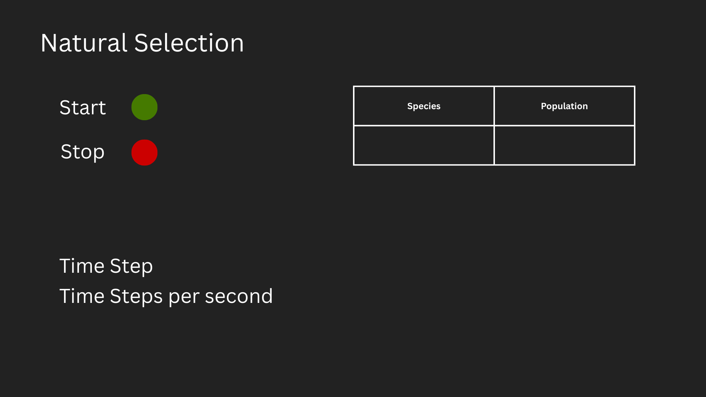

Advanced Graph Display
